Practical 23: Working with ImageViews and RadioButtons

Task 1: Spanish Quiz
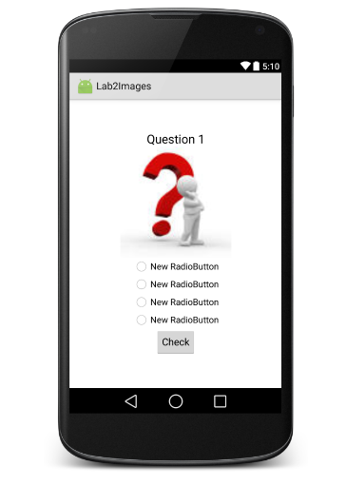 | 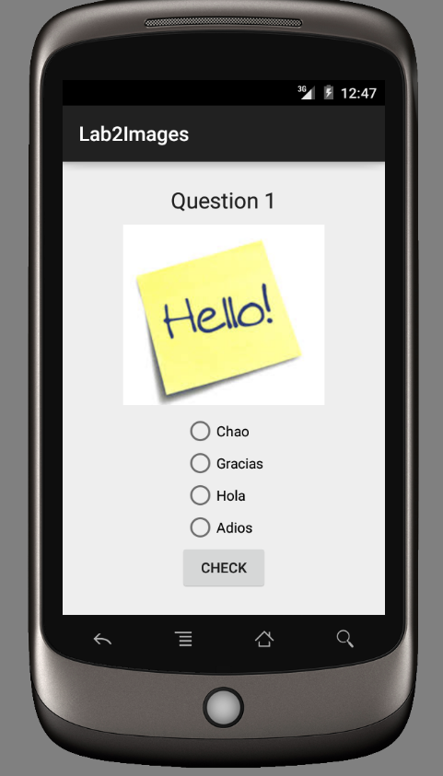 | 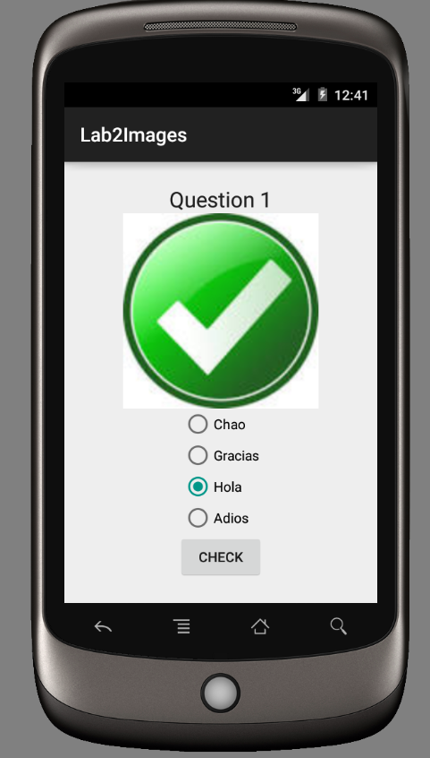
Design Time | Run time | After the button click

Load an image at design time
Copy and paste your images into the drawable folder in the project window. They must have lowercase file names.
Drop an ImageView on your screen and either select the src through the properties window; your images are visible in the project tab and at the bottom of the Color folder. Alternatively write your own xml code
android:src="@drawable/question"
Note: for images in the drawable folder you do not include the file extension.
For the background of your app try the following in the first container android:background="@drawable/bg2"

For radio buttons to work they must be inside a RadioGroup, this can have a vertical or horizontal orientation.
android:orientation="vertical"
If the radio group does not have a name give it one.
android:id="@+id/radioGroup"

To start with one of the buttons checked, I gave the first button the property
android:checked="true"

Load an image at run-time
image = (ImageView) findViewById(R.id.imageView);
image.setImageResource(R.drawable.hello);

Setting the text of a radio button at run time
RadioButton rb1 = (RadioButton) findViewById(R.id.radioButton1);
rb1.setText("Chao");

Checking which radio button was selected
RadioGroup rg = (RadioGroup) findViewById(R.id.radioGroup);
int selected = rg.getCheckedRadioButtonId();
//find out which radio button was chosen
RadioButton chosen = (RadioButton) findViewById(selected);
Then you can ask for chosen.getText().

Task 2: Spanish Food
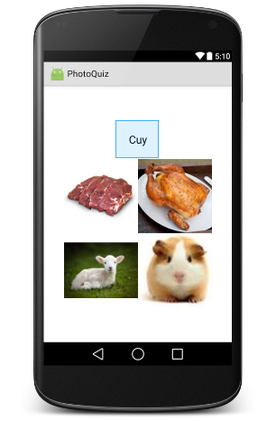 | 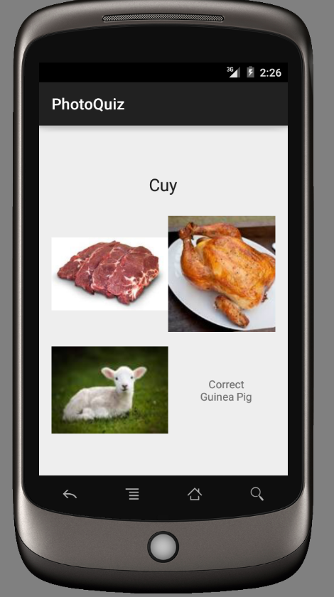 | 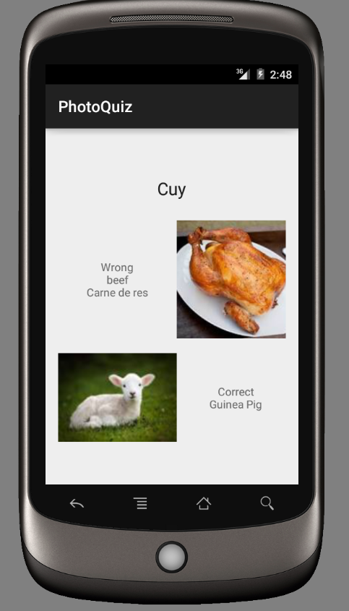
Design Time | Run time | After two attempts

Here is a question type that could be useful. These look like images but are actually textViews with the background property set.
android:background="@drawable/beef"

To get the layout of the pictures looking nice I used a grid layout
<GridLayout
android:layout_width="wrap_content"
android:layout_height="wrap_content"
android:columnCount="2"
android:rowCount="2">
<TextView
android:layout_width="150dp"
android:layout_height="150dp"
android:id="@+id/textView1"
android:layout_row="0"
android:layout_column="0"
android:background="@drawable/beef" />

Make each TextView clickable, here is centering text, giving a message and getting rid of the picture in java code
tv4.setGravity(Gravity.CENTER);
tv4.setBackground(null);
tv4.setText("Correct\nGuinea Pig");

Spanish words:
Lamb Cordero
Pork Cerdo
Guinea pig Cuy
Beef Carne de res

